**Per Frame Scripting**

These are demonstrations with the <SCRIPT> node that contains JavaScript and is called for every frame. In each case the <TimeSensor>’s time value is routed to the <SCRIPT> node. The time will be a value between 0 and the cycleInterval. Thus if the cycleInterval is 10 seconds, then the value sent to the <SCRIPT> node will be between 0 and 10, and repeat if the <TimeSensor>’s ‘loop’ Boolean is set to ‘true’. Users are encouraged to modify the JavaScript code.

**JavaScript_PerFrame_01_ProceduralAnim.x3d**

There are two objects a cone and a sphere, both animated by JavaScript. The cone follows a sine curve and the sphere moves from left to right to left. The sphere also changes color controlled inside the <SCRIPT> node’s JavaScript. There is no interactivity.

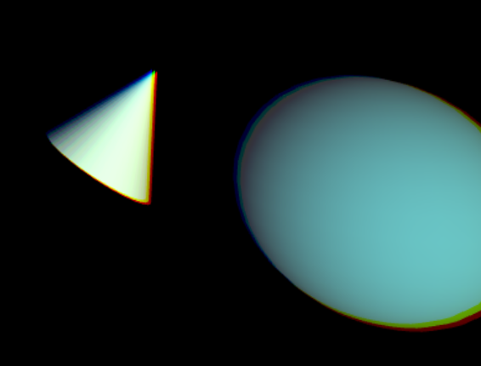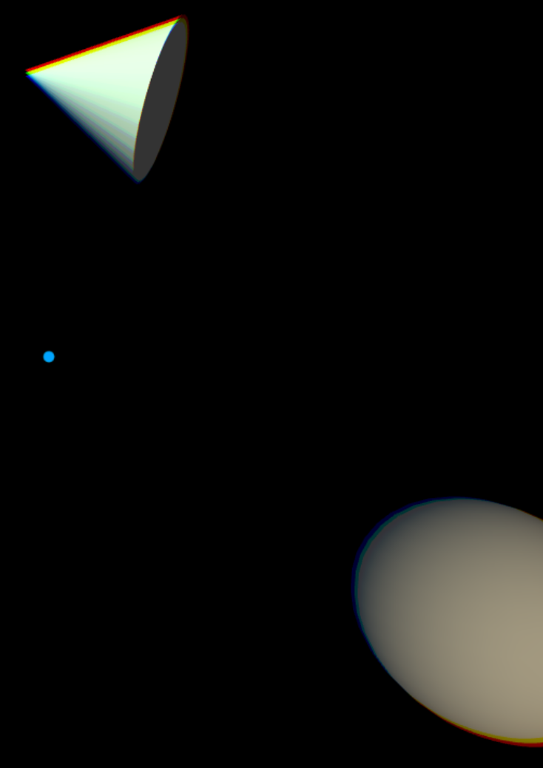

**JavaScript_PerFrame_02_LaunchSphere.x3d**

The demo begins with a sphere remaining in front of the viewer. The Cylinder color animates from red to white.

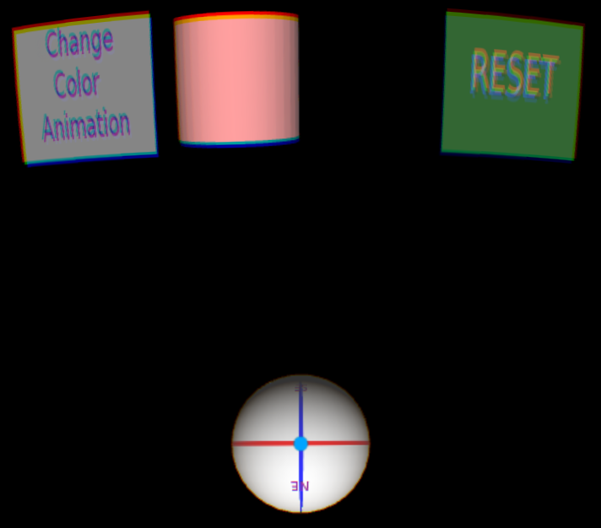

Tapping the GearVR Touch Pad launches the sphere as it is no longer directly in front of the user. Tapping the Touch Pad again when the user view (blue dot) is over the sphere ‘captures’ the sphere and it is now in front of the viewer, but further out.

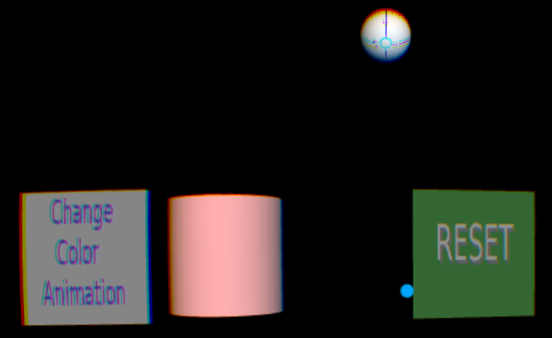

Rolling over “Reset” highlights the button as a visual cue to the user that it’s interactive.

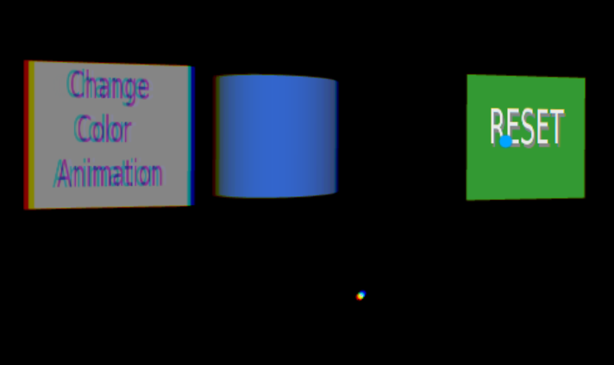

Clicking on “Reset” brings the sphere back.

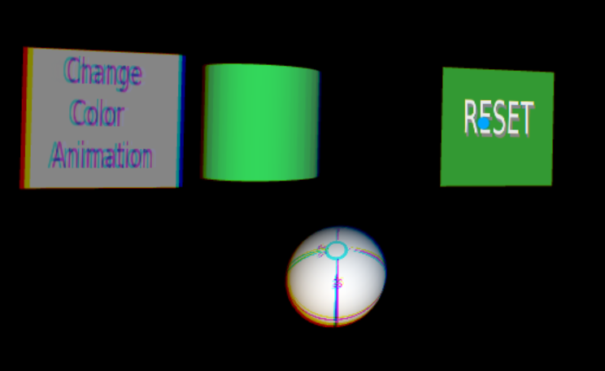

Rolling over the “Change Color Animation” button highlight it as a visual cue. Clicking it changes the animated colors over the sphere to be from green to blue. Clicking it again changes it back to animate it between red and white.

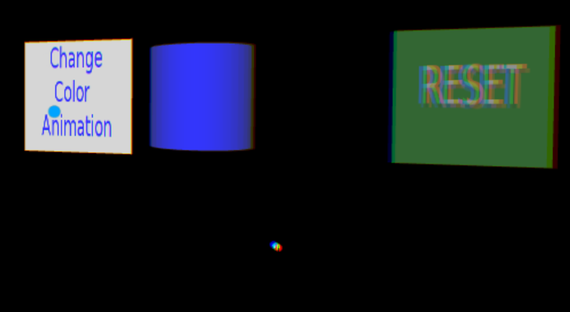

**JavaScript_PerFrame_03_TimeStamp.x3d**

The Cone navigates a rectangular pattern using Interpolators (key frame animation), not the <SCRIPT> node. This helps test that previous functionality still works.

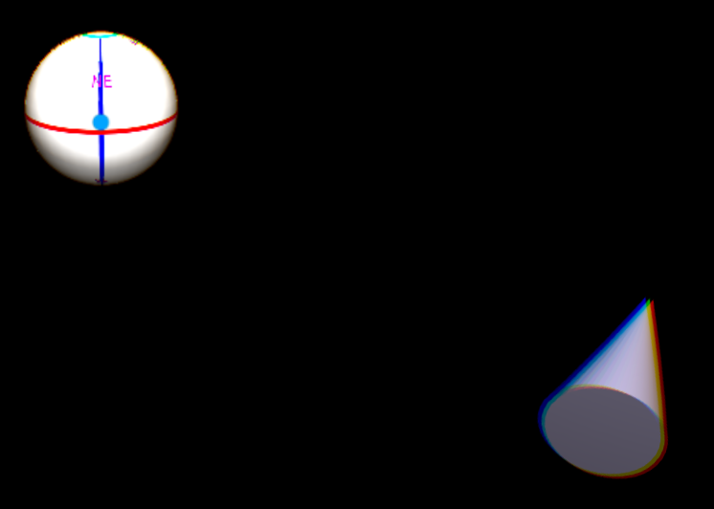

The color of the cone is however controlled by the <SCRIPT> node using JavaScript to cycle through various colors.

This demo also uses the ‘timestamp’ parameter that can be optionally passed to the <SCRIPT> node with the current time. [Normally, only one parameter is passed, either a true/false value, or the <TimeSensor> time value]. The timestamp value controls the sphere’s rotation around the x-axis.

